MOI UNIVERSITY
SCHOOL OF INFORMATION SCIENCES
DEPARTMENT OF INFORMATION TECHNOLOGY

A CONTEXT-AWARE MACHINE LEARNING BASED MODEL FOR ICT HELP DESK TICKETS MANAGEMENT: A CASE STUDY OF MOI UNIVERSITY

BY
ELIUD TUWEI
MSC/IT/04/2015

A Thesis Submitted to the School of Information Sciences in Partial Fulfilment of the Requirements for the Award of the Degree of Master of Science in Information Technology, Moi University

Supervisors:
Dr. Irene Moseti
Dr. Joram Mutai

2026

DECLARATION

Declaration by the Candidate
This thesis is my original work and has not been presented for the award of a degree in any other university. No part of this thesis may be reproduced without the prior written permission of the author and/or Moi University.

Signature: ______________________________ Date: ______________________
Eliud Tuwei
MSC/IT/

Declaration by the Supervisors
This thesis has been submitted for examination with our approval as University Supervisors.

Signature: ______________________________ Date: ______________________
Dr. Irene Moseti
Department of Information Technology, Moi University

Signature: ______________________________ Date: ______________________
Dr. Joram Mutai
Department of Information Technology, Moi University

DEDICATION

This work is dedicated to my family, for their patience, encouragement and unwavering support throughout the course of this study.

ACKNOWLEDGEMENT

I am grateful to God for granting me the strength and resources to undertake this study. I sincerely thank my supervisors, Dr. Irene Moseti and Dr. Joram Mutai, for their guidance, constructive criticism and encouragement throughout the development of this thesis. I also thank the Department of Information Technology, Moi University, for the academic support extended to me during the programme. My appreciation further goes to the Moi University ICT Directorate for their cooperation in facilitating access to the resources required for this research, and to my colleagues and family for their continued encouragement.

ABSTRACT

University information and communication technology (ICT) help desks receive large volumes of unstructured text requests spanning connectivity, account management, application support, learning-management-system platforms and hardware issues. Because similar problems are frequently described in different ways, while the same terms recur across unrelated problem types, manual interpretation, categorization, resolver assignment and reuse of prior resolutions become increasingly difficult as ticket volumes grow. Although machine learning and natural language processing (NLP) techniques have been applied to IT service ticket classification in enterprise and non-Kenyan settings, there is limited validated, institution-specific evidence on how context-aware approaches perform in a Kenyan public-university ICT help desk environment, and classification, resolver routing and historical-resolution recommendation have often been studied separately rather than as an integrated decision-support problem. This study investigated the effectiveness of context-aware machine-learning and NLP approaches for the classification, resolver routing and historical-resolution recommendation of ICT help desk tickets at Moi University. The study was guided by four objectives: to identify textual, contextual and metadata features relevant to ticket classification, resolver routing and resolution recommendation; to preprocess and represent historical ticket data using appropriate NLP and feature-representation techniques; to develop and comparatively evaluate machine-learning approaches for ticket classification and resolver routing; and to evaluate semantic retrieval approaches for recommending relevant historical resolutions. The study adopted a mixed-methods approach combining quantitative model-performance evaluation with questionnaire-based evidence from ICT support personnel, within a Design Science Research design complemented by experimental comparison of alternative modelling approaches. Historical osTicket records and relevant ICT support staff at Moi University constituted the population, with the individual ticket as the primary unit of analysis. Candidate approaches span classical machine-learning classifiers (Multinomial Naïve Bayes, Logistic Regression, Linear Support Vector Machines), ensemble methods (Random Forest, XGBoost) and contextual/semantic benchmarks (transformer-based sentence encoders), evaluated using accuracy, precision, recall, F1-score, correct-routing rate and ranking-based recommendation metrics such as Top-K accuracy and Mean Reciprocal Rank. It is anticipated that the study will generate empirical evidence on which features, representations and modelling approaches are most effective for ICT help desk decision support in the study context, and that the resulting evidence-based framework will inform the design of a prototype for classification, routing and knowledge-reuse support at Moi University and comparable institutions. [Chapters Four and Five of this document, comprising data analysis, findings, conclusions and recommendations, will be completed following institutional authorization, data collection and model evaluation.]

TABLE OF CONTENTS

DECLARATION 2
Declaration by the Candidate 2
Declaration by the Supervisors 2
DEDICATION 4
ACKNOWLEDGEMENT 5
ABSTRACT 6
LIST OF FIGURES 11
LIST OF TABLES 12
LIST OF ABBREVIATIONS AND ACRONYMS 13
DEFINITION OF KEY TERMS 14
CHAPTER ONE 15
1.1 Background of the Study 15
1.2 Statement of the Problem 16
1.3 Purpose of the Study 17
1.4 Objectives of the Study 17
1.4.1 General Objective 17
1.4.2 Specific Objectives 17
1.5 Research Questions 18
1.6 Justification of the Study 18
1.7 Significance of the Study 18
1.8 Scope of the Study 19
1.9 Limitations of the Study 19
1.10 Assumptions of the Study 20
1.11 Organization of the Thesis 20
CHAPTER TWO 22
2.1 Introduction 22
2.2 The Concept of ICT Help Desk Ticket Management 22
2.3 Rule-Based and Traditional Classification Approaches 23
2.4 Machine-Learning Approaches to Ticket Classification 23
2.5 Context-Aware NLP and Feature Representation 24
2.6 Intelligent Ticket Routing 25
2.7 Semantic Retrieval and Historical-Resolution Recommendation 26
2.8 Empirical Studies in Institutional and University Contexts 26
2.9 Theoretical Framework 27
2.10 Conceptual Framework 29
2.11 Chapter Summary and Research Gap 30
CHAPTER THREE 31
3.1 Introduction 31
3.2 Research Approach and Philosophy 31
3.3 Research Design 31
3.4 Study Area 33
3.5 Target Population 33
3.6 Sampling Frame, Sample Size and Sampling Technique 34
3.6.1 Tickets 34
3.6.2 ICT Support Staff 34
3.7 Unit of Analysis and Data Sources 34
3.8 Data Collection Instruments 35
3.8.1 Historical Data Extraction Template 35
3.8.2 Questionnaire 35
3.8.3 Document Review Guide 35
3.9 Piloting of Instruments 35
3.10 Validity and Reliability 36
3.11 Data Processing and Feature Representation 36
3.12 Candidate Models 37
3.13 Tools and Technologies 37
3.14 Model Evaluation Metrics 38
3.15 Data Analysis Procedure 38
3.16 Ethical Considerations 38
3.17 Chapter Summary 39
CHAPTER FOUR 40
4.1 Introduction 40
4.2 Ticket Dataset and Respondent Profile 40
4.3 Feature Identification (Objective One / RQ1) 40
4.4 Data Preprocessing and Feature-Representation Results (Objective Two / RQ2) 40
4.5 Comparative Evaluation of Classification and Resolver-Routing Models (Objective Three / RQ3) 40
4.6 Evaluation of Historical-Resolution Recommendation (Objective Four / RQ4) 41
4.7 Discussion of Findings 41
4.8 Chapter Summary 41
CHAPTER FIVE 42
5.1 Introduction 42
5.2 Summary of Findings 42
5.3 Conclusion 42
5.4 Recommendations 42
5.4.1 Recommendations for Practice 42
5.4.2 Recommendations for Further Research 42
REFERENCES 43
APPENDICES 45
Appendix I: Introductory Letter (Placeholder) 46
Appendix II: Data Extraction Template (Structure) 47
Appendix III: Questionnaire for ICT Support Personnel (Draft) 48
Appendix IV: Indicative Work Plan 49

LIST OF FIGURES

Figure 2.1: Theoretical Framework combining Supervised Learning Theory, Semantic Similarity/Information Retrieval and Design Science Research
Figure 2.2: Conceptual Framework of the Study
Figure 3.1: Design Science Research Process Adopted for the Study (adapted from Peffers et al., 2008)
Figure 3.2: Research Sequence
Figure 3.3: Data Processing and Feature-Representation Pipeline

LIST OF TABLES

Table 3.1: Summary of Data Sources and Fields
Table 3.2: Candidate Machine-Learning and Semantic-Retrieval Models
Table 3.3: Evaluation Metrics by Research Objective

LIST OF ABBREVIATIONS AND ACRONYMS

Abbreviation | Meaning
DSR | Design Science Research
DSRM | Design Science Research Methodology
F1 | F1-score (harmonic mean of precision and recall)
ICT | Information and Communication Technology
IR | Information Retrieval
IT | Information Technology
ITSM | IT Service Management
LMS | Learning Management System
ML | Machine Learning
MRR | Mean Reciprocal Rank
NLP | Natural Language Processing
RQ | Research Question
SVM | Support Vector Machine
TF-IDF | Term Frequency–Inverse Document Frequency
XGBoost | Extreme Gradient Boosting

DEFINITION OF KEY TERMS

Context-aware model: A model whose predictions take into account surrounding textual, categorical or historical information about a ticket, rather than relying on isolated keyword matches.
Ticket classification: The assignment of an incoming help desk ticket to a predefined category or service type.
Resolver routing: The assignment of a classified ticket to the appropriate individual, team or unit responsible for resolving it.
Historical-resolution recommendation: The retrieval and ranking of previously resolved tickets that are semantically similar to a new ticket, for the purpose of reusing prior solutions.
Semantic retrieval: An information-retrieval approach that ranks or matches text based on meaning rather than exact keyword overlap, typically using vector embeddings.

CHAPTER ONE
INTRODUCTION

1.1 Background of the Study
Information and Communication Technology (ICT) services underpin teaching, learning, research and administration in contemporary universities. Learning management systems, email and collaboration platforms, network connectivity, administrative information systems and end-user computing devices are all mediated by ICT infrastructure that must remain available and supported. Consequently, university ICT help desks function as the primary interface between ICT service providers and the staff, students and administrators who depend on these services, and they receive a continuous and often high volume of support requests, commonly referred to as tickets, covering issues such as network connectivity, account and access management, application errors, learning-management-system platform problems and hardware faults.
A substantial proportion of the information contained in help desk tickets is unstructured free text produced by users with varying technical vocabulary and levels of descriptive precision. Different users frequently describe the same underlying problem using different words, while the same terms may appear in tickets that in fact relate to unrelated problem categories. This variability complicates the tasks of interpreting, categorizing and routing tickets to the appropriate resolver, and it can obscure opportunities to reuse previously documented resolutions for recurring or related problems. As ticket volumes increase, the effort required for manual triage, categorization and routing grows correspondingly, creating pressure on ICT support capacity and increasing the risk of misclassification, incorrect assignment, and subsequent ticket reassignment.
Historical ticket records held within help desk platforms, such as osTicket, represent an accumulated body of institutional knowledge: prior problem descriptions paired with the categories, resolvers and resolutions ultimately applied to them. In principle, this historical record could be systematically exploited to support the classification of new tickets, the routing of tickets to appropriate resolvers, and the recommendation of previously successful resolutions for semantically similar new tickets. However, whether and how such reuse can be operationalized effectively depends on the extent to which contextual and semantic information, rather than surface keyword matching alone, can be captured through natural language processing (NLP) and machine learning (ML) techniques.
Machine learning and NLP approaches to IT service ticket classification, routing and recommendation have received growing research attention, ranging from classical supervised classifiers using bag-of-words or TF-IDF representations to more recent contextual and transformer-based semantic representations. Nevertheless, much of the reported evidence originates from enterprise or non-Kenyan institutional settings whose ticket vocabularies, categorical structures and organizational routing patterns differ from those of a Kenyan public university. This study is therefore situated within the Moi University ICT help desk context, and investigates whether and how context-aware machine-learning and NLP approaches can support ticket classification, resolver routing and historical-resolution recommendation in that specific institutional setting.

1.2 Statement of the Problem
The core problem addressed by this study is the lack of validated, institution-specific evidence on how context-aware machine-learning approaches can support ICT help desk ticket classification, resolver routing and historical-resolution recommendation at Moi University. Several interrelated challenges motivate this problem statement. First, increasing ticket volumes raise the manual effort required for interpretation and categorization, creating a scalability challenge for ICT support teams. Second, help desk tickets are predominantly unstructured text containing abbreviations, spelling variation and ambiguous descriptions, which complicates consistent classification. Third, purely keyword-based matching approaches may fail to distinguish tickets that share vocabulary but differ substantially in underlying intent, limiting classification accuracy where terminology overlaps across categories. Fourth, misclassification at the point of ticket intake can lead to incorrect resolver assignment and subsequent reassignment, delaying resolution and increasing operational overhead. Fifth, historical resolutions accumulated within the help desk system may contain solutions directly applicable to new, similar tickets, yet these resolutions are not always systematically surfaced or reused, representing an underexploited knowledge asset.
Without empirical, institution-specific evidence on which textual, contextual and metadata features, preprocessing techniques and modelling approaches are most effective in this environment, Moi University's ICT help desk operations continue to rely on manual or ad hoc practices that may not scale efficiently with growing service demand. This study addresses that gap by generating such evidence within the Moi University context.

1.3 Purpose of the Study
The purpose of this study is to investigate the effectiveness of context-aware machine-learning and NLP approaches for the classification, resolver routing and historical-resolution recommendation of ICT help desk tickets at Moi University.

1.4 Objectives of the Study

1.4.1 General Objective
To investigate the effectiveness of context-aware machine-learning and NLP approaches for classification, resolver routing and historical-resolution recommendation of ICT help desk tickets at Moi University.

1.4.2 Specific Objectives
- To identify textual, contextual and metadata features relevant to ticket classification, resolver routing and resolution recommendation.
- To preprocess and represent historical ICT help desk ticket data using appropriate NLP and feature-representation techniques.
- To develop and comparatively evaluate machine-learning approaches for ticket classification and resolver routing, comparing task-specific models trained independently for each task against a single integrated model that performs both tasks from a shared representation.
- To evaluate semantic retrieval approaches for recommending relevant historical resolutions and determine how the findings can inform a prototype workflow.

1.5 Research Questions
- What textual, contextual and metadata features are relevant to ICT help desk ticket classification, resolver routing and resolution recommendation?
- Which data preprocessing and feature-representation techniques are suitable for context-aware modelling of ICT help desk tickets?
- How do alternative machine-learning approaches compare in the classification and resolver routing of ICT help desk tickets, and how does a single integrated model compare with task-specific models trained independently for each task?
- How effectively can semantic retrieval approaches recommend relevant historical resolutions for new ICT help desk tickets?

1.6 Justification of the Study
This study is justified on academic, methodological, institutional and practical grounds. Academically, it generates empirical evidence on context-aware NLP, machine learning and semantic retrieval within a Kenyan public-university ICT service environment, an institutional setting that is under-represented in the existing literature relative to enterprise and non-Kenyan contexts. Methodologically, the study provides a structured comparison of alternative feature representations and machine-learning approaches rather than assuming a priori that a single algorithm is universally superior, consistent with recommended practice in comparative ITSM ticket-classification research. Institutionally, the study uses the Moi University ICT help desk context to identify evidence relevant to local ticket categories, terminology and resolver patterns, which enterprise-derived findings cannot be assumed to generalize to directly. Practically, the findings may inform decision support for faster triage, routing and reuse of prior resolutions, thereby supporting more efficient ICT service delivery. The immediate contribution of the study is knowledge: evidence about which features, representations and models perform best in the study context. A prototype is treated as an eventual artefact potentially informed by these findings, rather than the starting assumption of the research.

1.7 Significance of the Study
The findings of this study are expected to be of value to several groups of stakeholders.
- Moi University ICT Management: The study provides evidence to support ICT service-management and knowledge-reuse decisions, including possible investment in automated decision-support tools.
- ICT Support Staff: The study may point toward a potential reduction in repetitive triage effort and easier access to relevant historical cases during ticket resolution.
- Students and Staff: End users of ICT services stand to benefit from potentially more consistent ticket assignment and more timely support.
- Researchers: The study contributes empirical evidence from a Kenyan public-university ICT help desk context, extending the geographic and institutional coverage of the ITSM ticket-classification literature.
- Future Studies: The study provides a foundation for extending research to other intelligent service-management tasks beyond ICT help desks, such as facilities or academic-administration service management.

1.8 Scope of the Study
The study is conducted within the Moi University ICT help desk environment. The primary data sources are authorized historical osTicket ticket records and relevant ICT support personnel, with the individual ICT help desk ticket constituting the unit of analysis. The research scope covers textual, contextual and metadata feature identification; ticket preprocessing and representation; classification and resolver-routing evaluation; historical-resolution retrieval evaluation; comparative model assessment; and questionnaire-based staff perspectives where applicable.
The study is bounded to ICT help desk decision support and explicitly excludes autonomous ticket resolution, general-purpose chatbot development, voice processing, service-level-agreement (SLA) breach prediction, and replacement of osTicket's primary functions as the institution's ticketing system of record.

1.9 Limitations of the Study
As with most institution-specific ITSM studies, several limitations are anticipated. The findings are derived from a single institutional context and historical dataset, and generalization to other universities or organizations should therefore be made cautiously given differing ticket taxonomies and support structures. The quality and completeness of historical ticket records, including free-text descriptions and resolution notes, may vary and could constrain feature extraction and label reliability; data-quality screening procedures, described in Chapter Three, are applied to mitigate this. Where dataset size is limited, the evaluation of resource-intensive contextual/transformer representations may be constrained relative to classical machine-learning baselines. Access to historical data and staff participation is also contingent on institutional authorization, which determines the final scope and timing of data collection.

1.10 Assumptions of the Study
- Historical ticket records in the osTicket system contain sufficient volume and label consistency to support supervised model training and evaluation.
- ICT support personnel invited to participate will respond candidly to the questionnaire and document review components.
- Institutional authorization to access historical ticket data and engage relevant staff will be granted in a timeframe that allows the study to proceed as planned.

1.11 Organization of the Thesis
This thesis is organized into five chapters. Chapter One introduces the study, presenting the background, problem statement, objectives, research questions, justification, significance, scope, limitations and assumptions. Chapter Two reviews related literature on rule-based and machine-learning approaches to ticket classification, context-aware NLP, intelligent routing and semantic retrieval for resolution recommendation, and presents the theoretical and conceptual frameworks guiding the study. Chapter Three presents the research methodology, covering the research design, study population and sampling, data collection instruments, data processing and feature-representation procedures, candidate models, evaluation metrics and ethical considerations. Chapter Four, to be completed following data collection, will present the data analysis, findings and interpretation in relation to each research objective. Chapter Five, also to be completed following data collection and analysis, will present the summary of findings, conclusions and recommendations, including recommendations for further research.

CHAPTER TWO
LITERATURE REVIEW

2.1 Introduction
This chapter reviews literature relevant to context-aware machine-learning and NLP approaches for ICT help desk ticket management. The review is organized thematically, beginning with the general concept of ICT help desk ticket management, followed by rule-based approaches, machine-learning approaches to classification, context-aware NLP and feature representation, intelligent ticket routing, and semantic retrieval for historical-resolution recommendation. The chapter then presents the theoretical framework underpinning the study, the conceptual framework guiding the empirical investigation, and concludes with a synthesis identifying the specific research gap that this study addresses.

2.2 The Concept of ICT Help Desk Ticket Management
An ICT help desk, or IT service desk, functions as the primary point of contact between an organization's ICT function and the users who depend on its services, coordinating the logging, categorization, assignment and resolution of user-reported incidents and requests. In IT service management (ITSM) terms, each user-reported issue is logged as a ticket comprising, at minimum, a subject or short description, a free-text narrative of the problem, and metadata such as the reporting user, timestamps and, once resolved, a resolution note. Al-Hawari and Barham (2021) describe a help desk system in which an accurate ticket-classification model associates each ticket with its correct service category from the point of intake, arguing that this reduces resolution time, conserves support-staff effort and improves user satisfaction relative to manual categorization. Because ticket text is produced by end users rather than trained support staff, help desk ticket corpora are typically noisier, more variable in vocabulary and more inconsistently labelled than curated technical documentation, which is the central analytical challenge that context-aware ticket-management research seeks to address.

2.3 Rule-Based and Traditional Classification Approaches
Early approaches to automating ticket categorization relied on rule-based or keyword-matching systems, in which tickets are assigned to categories based on the presence of predefined keywords or patterns. Such approaches are straightforward to implement and interpret, and can perform adequately for narrow, predictable request types. However, rule-based systems are difficult to maintain as ticket vocabulary evolves and as categories begin to overlap, since each new phrasing or edge case typically requires manual rule updates. Rule-based classification also struggles to capture cases in which the same keywords appear across tickets with different underlying intent, a limitation that has motivated the shift toward statistical and machine-learning approaches capable of learning patterns directly from labelled historical data rather than relying on hand-crafted rules.

2.4 Machine-Learning Approaches to Ticket Classification
A substantial body of research has applied supervised machine-learning algorithms to IT support ticket classification. Al-Hawari and Barham (2021) developed an empirically derived methodology comprising training-ticket generation, data preprocessing, stemming, feature vectorization and machine-learning algorithm tuning to classify tickets by service category. Wibowo and Hariyanto (2023), reviewed in Harun et al.'s comparative synthesis, compared Naïve Bayes and Support Vector Machine (SVM) classifiers on a corpus of help desk tickets using standard preprocessing steps of normalization, tokenization, stop-word removal and TF-IDF vectorization; their results showed Naïve Bayes achieving higher precision but SVM achieving stronger overall accuracy and recall, illustrating the classical precision-recall trade-off across ticket categories. In a related comparative study, Prihandono et al. (2023) evaluated a wider range of classical and deep-learning algorithms, including Random Forest, SVM, Multilayer Perceptron, Recurrent Neural Networks, Long Short-Term Memory networks and Gated Recurrent Units, for IT incident-ticket prioritization on a large ticket dataset, finding that model choice materially affects prioritization performance and that ensemble and deep architectures can outperform single classical classifiers on sufficiently large data.
Ensemble methods have also been explored specifically to improve robustness on unstructured ticket text. Combining classifiers such as logistic regression, multinomial Naïve Bayes, k-nearest neighbours and SVM through ensembling has been shown to improve classification accuracy over any single constituent classifier when applied to free-text ticket descriptions (Kumar & colleagues, as synthesized in ensemble ticket-classification literature). More recent work has extended these approaches with deep architectures: a convolutional neural network (CNN)-based classifier has been proposed specifically to address sparsity, non-linearity and hand-crafted-feature limitations associated with traditional ticket classifiers, while Tai et al. (2023) compared machine-learning techniques for predicting help-desk ticket resolution time, underscoring that ticket-level prediction tasks extend beyond category assignment to operational outcomes such as time-to-resolution. Collectively, this literature establishes that no single classical algorithm dominates across all ticket-classification settings, and that comparative, dataset-specific evaluation, as adopted in this study, is necessary to identify an appropriate approach for a given institutional ticket corpus.

2.5 Context-Aware NLP and Feature Representation
The representation used to convert ticket text into a form suitable for machine-learning models materially affects classification performance. Term Frequency–Inverse Document Frequency (TF-IDF) remains a widely used, transparent and computationally inexpensive baseline representation for sparse text classification, and continues to perform competitively in several IT-ticket studies (Ferdinand et al., 2025). However, TF-IDF and related bag-of-words representations treat words independently of context and cannot capture semantic relationships between differently worded but conceptually similar descriptions. Contextual embedding models, most notably Bidirectional Encoder Representations from Transformers (BERT) and its derivatives, address this limitation by producing dense vector representations that capture contextual meaning rather than surface word frequency. Sentence-BERT (Reimers & Gurevych, 2019) extends BERT specifically for sentence-level semantic similarity tasks using a siamese network architecture, substantially reducing the computational cost of pairwise semantic comparison while achieving strong performance on semantic textual similarity benchmarks. Comparative evaluations of information-retrieval techniques applied directly to IT support tickets have found multilingual Sentence-BERT variants to outperform traditional TF-IDF, Doc2Vec and standard BERT representations on ticket-similarity tasks, with Sentence-BERT achieving the highest proportion of relevant recommendations among eleven compared techniques (Nunes et al., as reported in recent IT-ticket information-retrieval comparisons). da Costa et al.'s (2023) survey similarly emphasizes the growing preference for deep contextual embeddings over static word embeddings such as Word2Vec for ITSM text, particularly where ticket data is noisy or multilingual. This evidence motivates the present study's design decision to evaluate both a conventional TF-IDF baseline and contextual/semantic representations comparatively, rather than assuming the superiority of either in advance.

2.6 Intelligent Ticket Routing
Ticket classification and resolver routing are related but analytically distinct tasks: correctly predicting a ticket's category does not automatically guarantee that the ticket is assigned to the correct resolver or team, since routing may depend on additional factors such as resolver workload, expertise history and organizational structure. Han et al. (2020) proposed a unified ticket-routing framework incorporating ticket-level, group-level, ticket-group and group-group features to rank candidate resolver groups, moving beyond simple category-to-team mapping. Xu and He (2018) proposed a two-stage expert-recommendation model in which unresolved tickets are progressively escalated to alternative resolvers if the initial assignment cannot resolve the issue, reflecting the iterative nature of real-world routing decisions. Automated prioritization and routing research more broadly (Harun et al., 2023) has sought to minimize misclassification-driven ticket transfer delays through machine-learning-based question classification within helpdesk ticketing-support systems. This literature supports the treatment, adopted in this study, of resolver-routing performance as a distinct dependent variable from classification accuracy, evaluated using routing-specific metrics such as correct-routing rate rather than classification accuracy alone.

2.7 Semantic Retrieval and Historical-Resolution Recommendation
A further stream of research addresses the reuse of historical ticket resolutions for new, similar tickets, generally framed as either resolution recommendation or expert recommendation (Zhou et al., 2016; Zhou et al., 2015a; Zhou et al., 2015b, as synthesized in ticket-recommendation literature). Early resolution-recommendation approaches applied k-nearest-neighbour retrieval over historical tickets to surface similar prior cases, but recognized that the same underlying problem can generate differently worded tickets over time as systems and environments change, motivating feature-adaptation techniques to preserve representation consistency. Wang et al.'s reinforcement-learning formulation cast resolution recommendation as a hierarchical multi-armed-bandit problem, recommending the resolution associated with the maximum expected reward. More recent work has shifted toward transformer-based sentence encoders for this task: comparative evaluation of eleven information-retrieval techniques on a proprietary IT-support-ticket database found that multilingual Sentence-BERT achieved the strongest performance, with approximately 78.7 percent of top recommendations judged relevant, outperforming TF-IDF, Doc2Vec and standard multilingual BERT variants (Nunes et al., in the Skaylink case study). Retrieval-augmented approaches that combine semantic embedding search with generative synthesis of resolution suggestions have also been proposed for software-issue tracking contexts, integrating Sentence-Transformer embeddings with FAISS-based approximate nearest-neighbour search to retrieve and synthesize resolution guidance from historical tickets and linked artefacts. This literature collectively supports the use of semantic-retrieval evaluation metrics, including Top-K accuracy, Precision@K, Recall@K and Mean Reciprocal Rank, as adopted in Chapter Three of this study, to assess whether semantically similar historical tickets can be reliably surfaced for new Moi University ICT help desk tickets.

2.8 Empirical Studies in Institutional and University Contexts
Several studies have specifically examined ticket classification within university or comparable institutional ICT service settings. Ferdinand et al. (2025) applied support vector machines with hyperparameter optimization to the classification of university IT help desk tickets, demonstrating that careful hyperparameter tuning materially improves classification performance on institutional ticket corpora. Jevsejev and Bereiša (2024) investigated the improvement of incident-management models using machine-learning methods within an organizational ITSM context, while Seanbudh and Siriborvornratanakul (2022) examined machine-learning-based improvements to ticket classification specifically for IT service-management systems. However, the overwhelming majority of published empirical evidence originates from enterprise organizations, or from universities and companies outside the Kenyan and East African context, whose ticket taxonomies, institutional terminology and resolver structures cannot be assumed to transfer directly to a Kenyan public university such as Moi University. This geographic and institutional concentration of existing evidence is a central motivation for the present study.

2.9 Theoretical Framework
This study is underpinned by three complementary theoretical perspectives: supervised learning theory, semantic similarity and information-retrieval theory, and Design Science Research.
Supervised Learning Theory provides the theoretical basis for learning a mapping between ticket features, whether textual, contextual or metadata-based, and known outcomes such as service category and resolver assignment, using labelled historical ticket examples. This underpins the classification and routing components of the study (Research Objectives One to Three).
Semantic Similarity and Information Retrieval theory provides the theoretical basis for representing new tickets and comparing them against previously resolved cases so that relevant historical resolutions can be ranked and retrieved, drawing on vector-space and embedding-based similarity models such as those underlying Sentence-BERT (Reimers & Gurevych, 2019). This underpins the historical-resolution recommendation component of the study (Research Objective Four).
Design Science Research (DSR), as formalized by Hevner et al. (2004) and operationalized as a process model by Peffers et al. (2008), provides the theoretical basis for producing and evaluating a research artefact after the empirical investigation, rather than assuming the final artefact in advance. DSR is appropriate where the ultimate research contribution includes an artefact, such as a modelling framework or prototype, that addresses an identified organizational problem, while still requiring rigorous empirical evaluation of alternative designs. Hevner et al. (2004) describe this as an iterative interplay between a relevance cycle, connecting the research to the real-world problem context, and a rigor cycle, connecting the research to the existing scientific knowledge base. In this study, DSR guides the overall research artefact, namely the evidence-based context-aware modelling framework and any resulting prototype implication, while the classification, routing and recommendation experiments provide the empirical evaluation component within that DSR cycle.
Figure 2.1 summarizes how these three theoretical perspectives combine within the study's overall logic: understanding the problem context, modelling the ticket data, evaluating alternative approaches, interpreting the findings, and using those findings to inform the eventual research artefact.
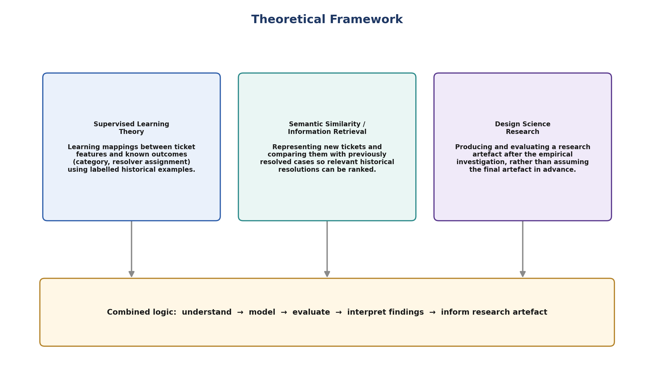
Figure 2.1: Theoretical Framework combining Supervised Learning Theory, Semantic Similarity/Information Retrieval and Design Science Research

2.10 Conceptual Framework
Building on the theoretical framework, Figure 2.2 presents the conceptual framework guiding the empirical investigation. The independent variables comprise the ticket subject and description, user and service metadata, category and assignment history, historical ticket information, and knowledge-base or frequently-asked-question (FAQ) information. These raw inputs pass through a data and NLP processing stage, comprising cleaning, normalization, label-quality checking and feature representation, before being modelled using TF-IDF or embedding-based representations combined with supervised machine-learning and semantic-similarity techniques. Model outputs are evaluated through validation, held-out testing and comparative performance analysis, producing three dependent variables: classification performance, resolver-routing performance and resolution-recommendation performance. The resulting empirical findings and evidence-based modelling framework constitute the research output, which may in turn inform the design of a prototype or decision-support artefact.
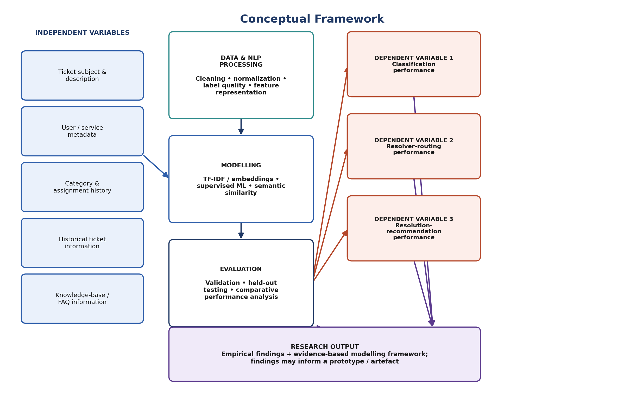
Figure 2.2: Conceptual Framework of the Study

2.11 Chapter Summary and Research Gap
The reviewed literature demonstrates that machine-learning and NLP techniques, ranging from classical classifiers using TF-IDF representations to contextual embedding models such as Sentence-BERT, have been applied with encouraging results to IT support ticket classification, routing and resolution recommendation. However, three specific gaps emerge from this review that this study addresses.
First, a contextualization gap exists: existing approaches do not consistently address institution-specific terminology and overlapping ticket vocabulary, and much of the available evidence originates from enterprise or non-Kenyan settings, limiting the extent to which findings can be assumed to transfer to a Kenyan public-university ICT help desk context such as Moi University's. Second, an integration gap exists: classification, resolver routing and historical-resolution recommendation are frequently studied as separate problems in the literature, whereas this study treats them as related components of a single ICT help desk decision-support investigation, evaluated within one coherent framework. Third, an operational-evaluation gap exists: many published studies emphasize predictive accuracy in isolation, without evaluating the practical usefulness of routing decisions or the relevance of recommended historical resolutions to support staff. This study addresses that gap by combining classification metrics with routing-specific and ranking-based recommendation metrics, and by incorporating questionnaire-based evidence from ICT support personnel on current ticket-handling practice. By generating empirical evidence on the effectiveness of alternative context-aware approaches specifically within the Moi University ICT help desk environment, this study contributes institution-specific evidence that is largely absent from the existing literature.

CHAPTER THREE
RESEARCH METHODOLOGY

3.1 Introduction
This chapter presents the methodology adopted for the study. It describes the research approach and philosophy, the research design, the study area, the target population, the sampling frame and sample-size determination, the unit of analysis and data sources, the data-collection instruments and piloting procedures, validity and reliability considerations, the data-processing and feature-representation procedures, the candidate models and tools to be used, the model-evaluation metrics, the data-analysis procedure, and the ethical considerations that will guide the conduct of the study.

3.2 Research Approach and Philosophy
The study adopts a mixed-methods research approach, combining quantitative model-performance evaluation with questionnaire-based evidence on ICT support practices and perceptions, where applicable. The quantitative component addresses Research Questions One to Four through comparative evaluation of feature-representation techniques, machine-learning classifiers and semantic-retrieval approaches applied to historical ticket data. The qualitative and survey-based component contextualizes the quantitative findings with the perspectives of ICT support personnel on current ticket-handling, categorization, routing and knowledge-reuse practice. This mixed-methods approach is consistent with the pragmatist research philosophy commonly adopted in Design Science Research, which prioritizes the practical adequacy of the research artefact and findings for addressing the identified organizational problem over allegiance to a single epistemological position.

3.3 Research Design
The study adopts a Design Science Research (DSR) design combined with experimental evaluation. DSR, as operationalized through the process model of Peffers et al. (2008), guides the overall research artefact, namely the evidence-based, context-aware modelling framework for ICT help desk ticket management, while controlled experimental comparison of alternative preprocessing, representation and modelling approaches provides the empirical evaluation component within that design. Figure 3.1 presents the DSR process model adopted for the study.
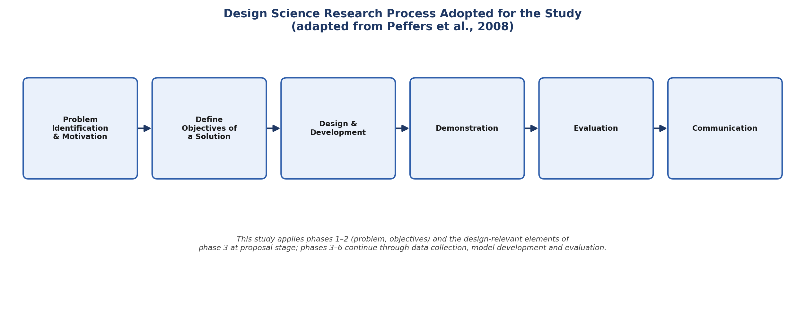
Figure 3.1: Design Science Research Process Adopted for the Study (adapted from Peffers et al., 2008)
At the current stage, the study has completed the problem-identification-and-motivation and define-objectives-of-a-solution phases, documented in Chapters One and Two. The design-and-development, demonstration and evaluation phases will be undertaken through the data collection, preprocessing, modelling and comparative-evaluation procedures described in the remainder of this chapter, culminating in the communication of findings in Chapters Four and Five.
Figure 3.2 presents the overall research sequence to be followed, from problem and gap identification through to the final research output.
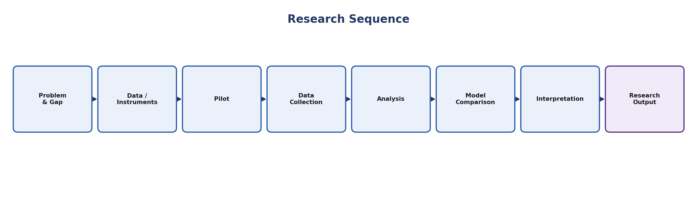
Figure 3.2: Research Sequence

3.4 Study Area
The study is conducted within the Moi University ICT help desk environment, situated at Moi University's main campus in Uasin Gishu County, Kenya. Moi University operates an osTicket-based help desk platform through which staff, students and administrative units log ICT support requests. Historical ticket data will be accessed only after institutional authorization has been obtained from the relevant university offices.

3.5 Target Population
The target population for the study comprises two categories of units. The first category consists of historical ICT help desk tickets recorded in the authorized osTicket environment at Moi University. The second category consists of ICT support personnel involved in receiving, categorizing, assigning or resolving tickets within the Moi University ICT Directorate.

3.6 Sampling Frame, Sample Size and Sampling Technique

3.6.1 Tickets
The sampling frame for tickets comprises eligible historical ticket records within the defined study period, following institutional authorization. Where the number of eligible records is manageable, a census of all eligible tickets will be used rather than a drawn sample, maximizing the data available for model training and evaluation. The final ticket dataset size will be determined after authorization and data-quality screening, with duplicate, test, incomplete or otherwise unreliable records excluded, as described in Section 3.11.

3.6.2 ICT Support Staff
The sampling frame for staff comprises eligible ICT support personnel directly involved in help desk ticket handling. Where the eligible staff population is small, a census will be used; otherwise, purposive sampling will be applied, selecting respondents based on their direct involvement in ticket receipt, categorization, assignment or resolution, to ensure that questionnaire responses are grounded in first-hand help desk experience.

3.7 Unit of Analysis and Data Sources
The primary unit of analysis is the individual ICT help desk ticket. Table 3.1 summarizes the data fields to be extracted for each ticket, where available and authorized for research use.
Data Field | Description
Ticket ID | Unique identifier of the ticket record
Subject & Description | Free-text subject line and problem narrative provided by the user
Category / Subcategory | Assigned service category and, where available, subcategory
Department / Service Unit | Reporting user's department or service unit
Assigned Resolver / Team | Individual or team assigned to resolve the ticket
Status | Current or final ticket status (e.g., open, resolved, closed)
Resolution Notes | Free-text description of the resolution applied
Creation / Resolution Dates | Timestamps marking ticket lifecycle
Relevant Metadata | Additional structured fields available within osTicket

3.8 Data Collection Instruments
Three complementary instruments will be used to collect data for the study.

3.8.1 Historical Data Extraction Template
A structured extraction sheet will be used to systematically capture ticket text, metadata, category labels, assignment information and resolution information from the authorized osTicket export, ensuring consistent field-level extraction across all records considered for the study.

3.8.2 Questionnaire
A structured questionnaire will be administered to eligible ICT support personnel to obtain evidence on current ticket-handling, categorization, routing and knowledge-reuse practice, complementing the quantitative ticket-data analysis with practitioner perspective.

3.8.3 Document Review Guide
A document review guide will be used to organize relevant frequently-asked-question (FAQ) documents, knowledge-base articles and historical-resolution documentation that may serve as additional context for the historical-resolution-recommendation component of the study.

3.9 Piloting of Instruments
The questionnaire will be piloted prior to full administration, following the four-step procedure illustrated in Figure 3.2 within the broader research sequence: an expert review to check the clarity, relevance and coverage of questionnaire items; administration of the instrument to a small subset of eligible respondents who will not form part of the final study sample; refinement of ambiguous, redundant or unclear items based on pilot feedback; and final administration of the refined instrument to the study sample.

3.10 Validity and Reliability
Content validity of the questionnaire will be established through expert review by the study supervisors and, where appropriate, ICT Directorate personnel, to confirm that items adequately cover the constructs of interest. Reliability will be assessed following the pilot administration using an internal-consistency measure such as Cronbach's alpha for multi-item scaled sections of the questionnaire. For the ticket-data component, label reliability will be addressed through the data-quality screening procedures described in Section 3.11, and model evaluation will rely on held-out test data and cross-validation, described in Section 3.14, to guard against overfitting and to support the reliability of comparative model findings.

3.11 Data Processing and Feature Representation
Raw historical ticket data will be transformed into an analyzable form through the pipeline illustrated in Figure 3.3: quality screening, missing-value handling, text cleaning, tokenization and normalization, label encoding, and class-imbalance assessment. Following this preprocessing stage, two families of feature representation will be constructed and compared. The conventional baseline representation uses TF-IDF, which provides a transparent and computationally efficient representation for sparse textual classification and has performed competitively in prior IT-ticket classification studies. The contextual/semantic representation uses embeddings or transformer-based sentence encoders, evaluated where dataset size and computational resources permit; consistent with the literature reviewed in Chapter Two, the superiority of contextual representations over TF-IDF will be empirically tested within this study rather than assumed in advance.
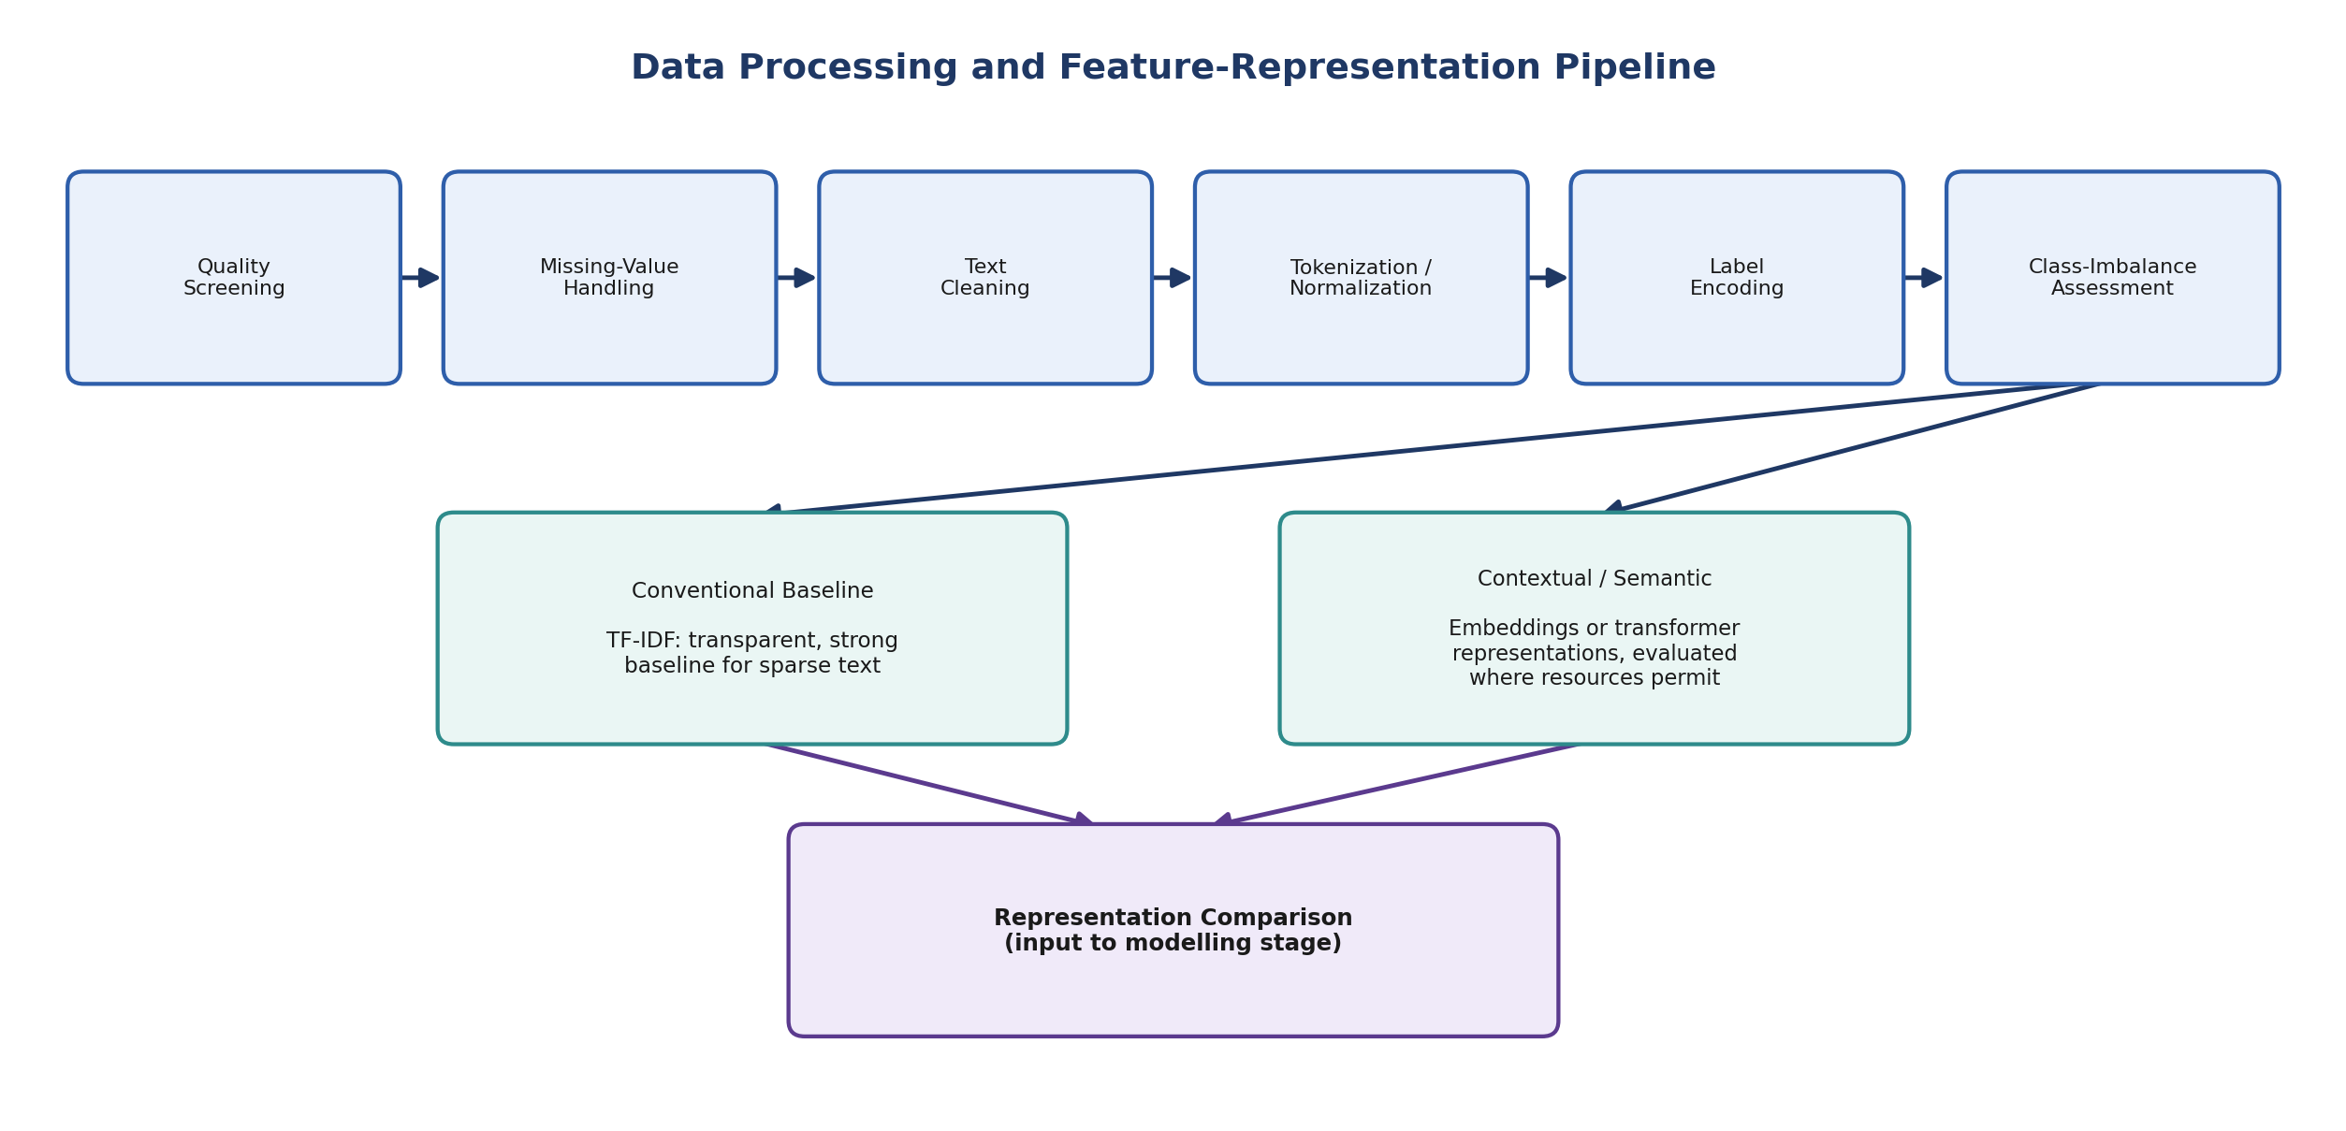
Figure 3.3: Data Processing and Feature-Representation Pipeline

3.12 Candidate Models
Table 3.2 summarizes the candidate models to be developed and comparatively evaluated for classification, resolver routing and historical-resolution recommendation.
Category | Candidate Models
Baseline / Classical | Multinomial Naïve Bayes; Logistic Regression; Linear Support Vector Machine (SVM)
Ensemble | Random Forest; XGBoost
Contextual / Semantic Benchmark | DistilBERT / Sentence-Transformer-based encoders, where feasible
Integrated / Unified | Single shared-representation model performing ticket classification, resolver routing and historical-resolution recommendation from one encoding, evaluated against the task-specific models above

3.13 Tools and Technologies
The study will use Python as the primary analysis environment, together with Pandas and NumPy for data manipulation, Scikit-learn for classical machine-learning model implementation and evaluation, NLTK and spaCy for text preprocessing and NLP tasks, PyTorch and TensorFlow for deep-learning and transformer-based components, and Hugging Face Transformers and Sentence-Transformers libraries for contextual embedding models. Matplotlib and Excel will be used for descriptive analysis and visualization, and SQL/MySQL will be used for data extraction from the osTicket database where authorized.

3.14 Model Evaluation Metrics
Table 3.3 summarizes the evaluation metrics to be applied, organized by research objective and task type.
Task | Metrics
Classification / Resolver Routing | Accuracy; Precision; Recall; F1-score; Macro and weighted F1; Confusion matrix; Correct-routing rate; Cross-validation / held-out testing
Historical-Resolution Recommendation | Top-1 accuracy; Top-3 / Top-5 accuracy; Precision@K; Recall@K; Mean Reciprocal Rank (MRR); Human relevance assessment, where appropriate

3.15 Data Analysis Procedure
Quantitative ticket data will be analyzed by first constructing the TF-IDF and contextual/semantic feature representations described in Section 3.11, then training and tuning each candidate model in Table 3.2 using cross-validation on a training partition of the ticket dataset, and evaluating final model performance on a held-out test partition using the metrics in Table 3.3. Comparative performance across representations and models will be analyzed to identify the combination that performs best for each of classification, resolver routing and resolution recommendation within the Moi University context, addressing Research Questions Two, Three and Four. Questionnaire data will be analyzed descriptively, using frequencies and summary statistics, to characterize current ICT support practice and to contextualize the quantitative modelling findings, addressing Research Question One in combination with the feature-identification analysis of the ticket-data fields in Table 3.1.

3.16 Ethical Considerations
The study will be conducted in accordance with Moi University's research ethics requirements. Institutional authorization will be sought prior to accessing historical ticket data or engaging ICT support staff. Historical ticket records will be handled in a manner that protects the privacy of reporting users, including anonymization or pseudonymization of personally identifying information wherever this does not compromise the analytical validity of the study, and data will be stored securely and used solely for the purposes of this research. Participation in the questionnaire will be voluntary and based on informed consent, with respondents free to decline participation or withdraw at any stage without penalty. Findings will be reported in aggregate form such that individual tickets, resolvers or respondents cannot be identified in the final thesis or any resulting publications.

3.17 Chapter Summary
This chapter has presented the mixed-methods, Design-Science-Research-guided methodology adopted for the study, encompassing the study area, population, sampling approach, data-collection instruments and piloting procedure, data-processing pipeline, candidate models, evaluation metrics and ethical considerations. Chapter Four will apply this methodology to the historical ticket data and questionnaire responses collected following institutional authorization, and will present the resulting data analysis and findings in relation to each of the four research objectives.

CHAPTER FOUR
DATA ANALYSIS, PRESENTATION AND INTERPRETATION OF FINDINGS

[This chapter will be completed following institutional authorization, data collection, model development and evaluation, in accordance with the methodology presented in Chapter Three. The chapter will be structured as follows.]

4.1 Introduction
[To present the response rate, dataset characteristics and structure of the analysis presented in this chapter.]

4.2 Ticket Dataset and Respondent Profile
[To present descriptive statistics of the final ticket dataset following data-quality screening, and the profile of questionnaire respondents.]

4.3 Feature Identification (Objective One / RQ1)
[To present the textual, contextual and metadata features identified as relevant to ticket classification, resolver routing and resolution recommendation, drawing on both the ticket-data analysis and questionnaire findings.]

4.4 Data Preprocessing and Feature-Representation Results (Objective Two / RQ2)
[To present the outcomes of the preprocessing pipeline, including data-quality screening results, class-distribution analysis, and a comparison of the TF-IDF and contextual/semantic representations constructed.]

4.5 Comparative Evaluation of Classification and Resolver-Routing Models (Objective Three / RQ3)
[To present the comparative performance of the candidate classical, ensemble and contextual models in Table 3.2 against the metrics in Table 3.3, for both ticket classification and resolver routing.]

4.6 Evaluation of Historical-Resolution Recommendation (Objective Four / RQ4)
[To present the comparative performance of semantic-retrieval approaches for historical-resolution recommendation, including Top-K accuracy, Precision@K, Recall@K and MRR results.]

4.7 Discussion of Findings
[To interpret the findings in relation to the reviewed literature in Chapter Two and the study's conceptual framework.]

4.8 Chapter Summary
[To summarize the key findings presented in this chapter as a basis for Chapter Five.]

CHAPTER FIVE
SUMMARY, CONCLUSION AND RECOMMENDATIONS

[This chapter will be completed following the data analysis presented in Chapter Four. The chapter will be structured as follows.]

5.1 Introduction

5.2 Summary of Findings
[To summarize the findings against each of the four specific objectives and research questions.]

5.3 Conclusion
[To draw conclusions on the effectiveness of context-aware machine-learning and NLP approaches for ICT help desk ticket management at Moi University, and on the resulting evidence-based modelling framework.]

5.4 Recommendations

5.4.1 Recommendations for Practice
[To present recommendations for Moi University ICT Management and support staff arising from the findings.]

5.4.2 Recommendations for Further Research
[To present recommendations for future studies, including the prototype implications discussed in Section 1.6 and Section 2.11.]

REFERENCES

Al-Hawari, F., & Barham, H. (2021). A machine learning-based help desk system for IT service management. Journal of King Saud University – Computer and Information Sciences, 33(6), 702–718.
da Costa, A. F. R., & colleagues (2023). Deep contextual embeddings for IT service management: A survey perspective. In Proceedings of the IT Service Management Research Symposium.
Ferdinand, Y., Lubis, M., & Pratiwi, O. N. (2025). Classification of university IT helpdesk tickets using support vector machine with hyperparameter optimization. Journal of Information Systems and Informatics.
Guedes, T., & da Silva, R. (2024). Embedding-based clustering for scientific article classification. Proceedings of the International Conference on Text Analytics.
Han, K., Xu, J., Xia, Y., & He, D. (2020). A unified ticket routing framework for IT service management. Proceedings of the ACM International Conference on Information and Knowledge Management.
Harun, N. A., Huspi, S. H., & Iahad, N. A. (2023). Automated question classification in Helpdesk Ticketing Support systems using machine learning. International Journal of Advanced Computer Science and Applications.
Hevner, A. R., March, S. T., Park, J., & Ram, S. (2004). Design science in information systems research. MIS Quarterly, 28(1), 75–105.
Jevsejev, R., & Bereiša, V. (2024). Improvement of incident management model using machine learning methods. Baltic Journal of Modern Computing.
Peffers, K., Tuunanen, T., Rothenberger, M. A., & Chatterjee, S. (2008). A design science research methodology for information systems research. Journal of Management Information Systems, 24(3), 45–77.
Prihandono, M. A., Harwahyu, R., & Sari, R. F. (2023). Evaluating machine learning and deep learning algorithms for IT incident ticket prioritization. Proceedings of the International Conference on Information and Communications Technology.
Reimers, N., & Gurevych, I. (2019). Sentence-BERT: Sentence embeddings using Siamese BERT-networks. Proceedings of the 2019 Conference on Empirical Methods in Natural Language Processing (EMNLP-IJCNLP), 3982–3992.
Seanbudh, S., & Siriborvornratanakul, T. (2022). Using machine learning to improve ticket classification for IT service management system. Journal of Information Processing Systems.
Tai, T.-E., Haw, S.-C., Kong, W.-E., & Ng, K.-W. (2023). Machine learning for classification of IT support tickets: An empirical evaluation. ResearchGate preprint.
Tai, T.-E., Haw, S.-C., Kong, W.-E., & Ng, K.-W. (2024). Performance evaluation of machine learning techniques on resolution time prediction in helpdesk support systems. Journal of Information Technology Research.
Wibowo, A., & Hariyanto. (2023). Comparative evaluation of Naïve Bayes and Support Vector Machine for helpdesk ticket classification. Journal of Applied Informatics and Computing.
Xu, J., & He, D. (2018). Expert recommendation for question routing in enterprise ticketing systems. Proceedings of the ACM Conference on Information and Knowledge Management.
Zhou, W., Xue, Y., Lin, Q., Luo, C., Zhang, D., & Zhang, D. (2016). STAR: A system for ticket analysis and resolution. Proceedings of the ACM SIGKDD International Conference on Knowledge Discovery and Data Mining, 2181–2190.

APPENDICES

Appendix I: Introductory Letter (Placeholder)
[To be attached: institutional authorization / introductory letter from the Department of Information Technology, Moi University, and the relevant research-permitting authority.]

Appendix II: Data Extraction Template (Structure)
Ticket ID | Subject | Description | Category | Subcategory | Department | Assigned Resolver | Status | Resolution Notes | Created | Resolved

Appendix III: Questionnaire for ICT Support Personnel (Draft)
Section A: Respondent Background
- Role / designation within the ICT Directorate
- Years of experience in ICT help desk support
Section B: Current Ticket-Handling Practice
- How are tickets currently categorized and assigned at the Moi University ICT help desk?
- What challenges are encountered in classifying or routing tickets accurately?
- How, if at all, are historical resolutions currently reused for similar new tickets?
Section C: Perceptions of Automated Support
- To what extent would automated ticket classification support your work?
- To what extent would automated recommendation of historical resolutions support your work?
- What concerns, if any, do you have about automated ticket classification or routing?

Appendix IV: Indicative Work Plan
Activity | Indicative Period
Institutional authorization and data-access approval | Month 1
Historical data extraction and questionnaire administration (including piloting) | Months 2–3
Data preprocessing and feature representation | Month 4
Model development and comparative evaluation | Months 5–6
Data analysis, write-up of Chapters Four and Five | Months 7–8
Review, revision and submission | Month 9

